Thank you for taking a crack at this, we appreciate you making the time and are excited to see what you come up with :)

The idea here is to understand how you work in your natural environment, without the pressure of producing an answer on-the-spot.

**Problem Statement**

One of the ways to understand the performance of a company is to ask the experience of their current customers. If the customers are delighted, they are expected to stay longer.

To measure the delight, Clarivate had rolled out survey in 2019 and 2020.

They survey had 5 rating questions, 2 text questions and 1 question on role of the respondent:

1. Clarivate Analytics provides me with information and insights we can rely on.
2. I have positive interactions with Clarivate Analytics.
3. Clarivate Analytics offers high quality products and services.
4. Clarivate Analytics is easy to do business with.
5. I receive value from Clarivate Analytics based on the products and services provided.
6. What is one thing Clarivate Analytics is doing well and should continue?
7. What is one thing you would like to see Clarivate Analytics change or improve to better meet your needs?
8. What is your role as a Clarivate Analytics' customer?

We present you the data with responses from 2019 and 2020 survey data.

We want you to analyse this data and create insights from the data. Typically, questions that should be answered can be and not limited to following:

1. How is the overall performance? Can you create a metric that describes the overall performance of the company?
2. How did the company perform in 2020 compared to previous year?
3. What are the top good and bad areas that customers have highlighted from the text questions? Create top 5 topics for each of good and bad areas.
4. Any other insights from the data?

You can make use of any external data with this data to be more insightful!

Expected Submission

We are flexible in terms of how you would like to present your output. The output can be in form of a deck (PowerPoint) or in excel document.

Please do not make either your solution or this problem statement publicly available by, for example, using github or bitbucket or by posting this problem to a blog or forum.

1. How is the overall performance? Can you create a metric that describes the overall performance of the company?

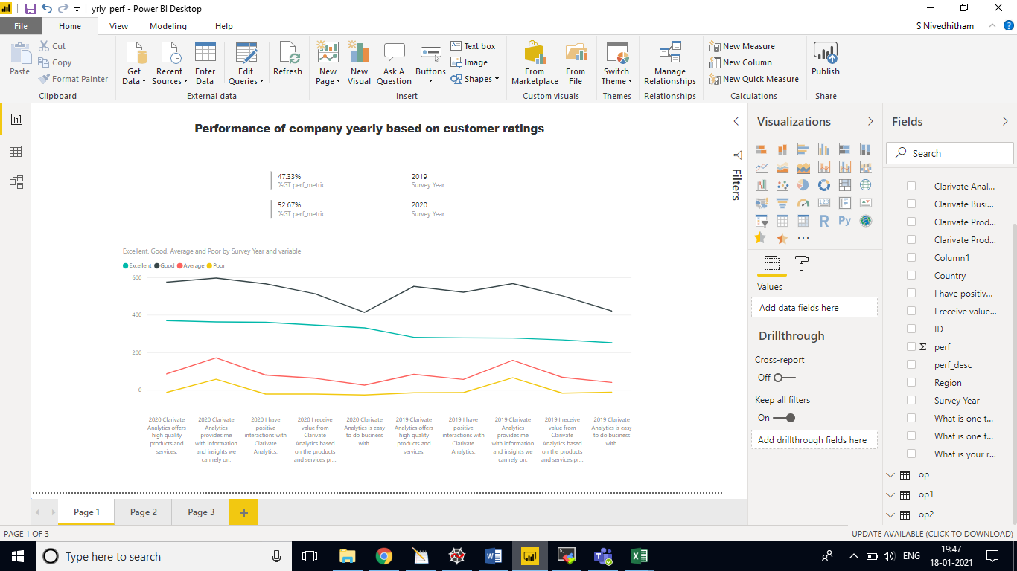

1. How did the company perform in 2020 compared to previous year?

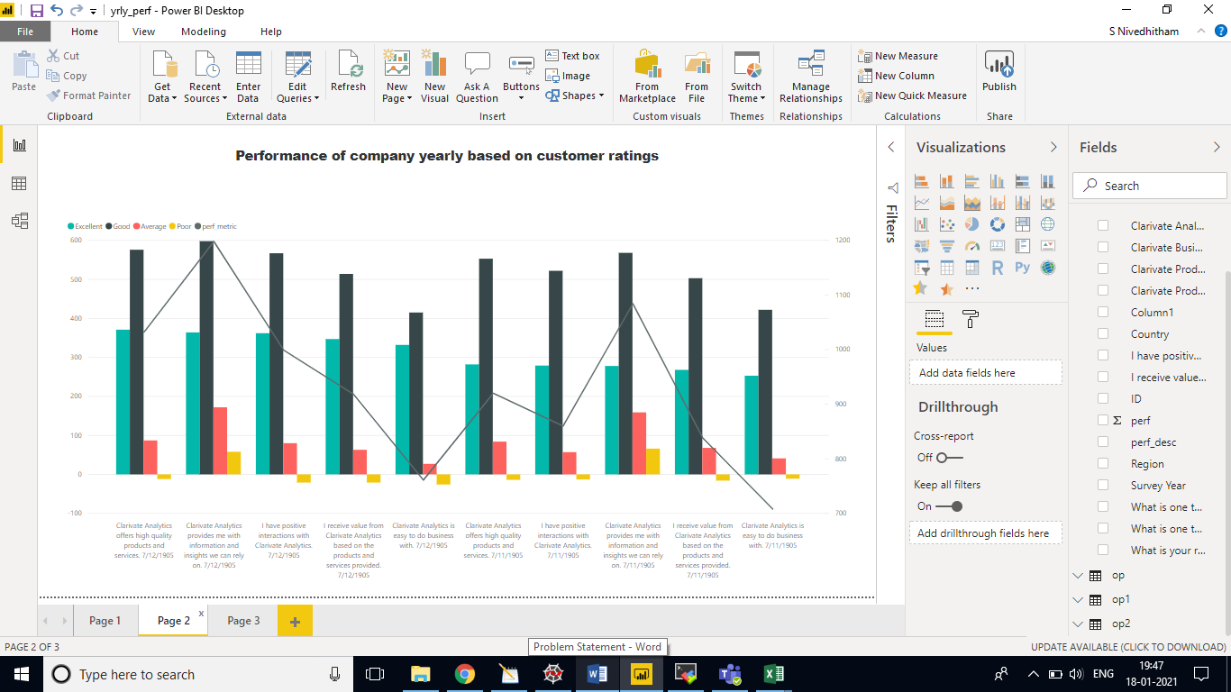

Insights from text questions

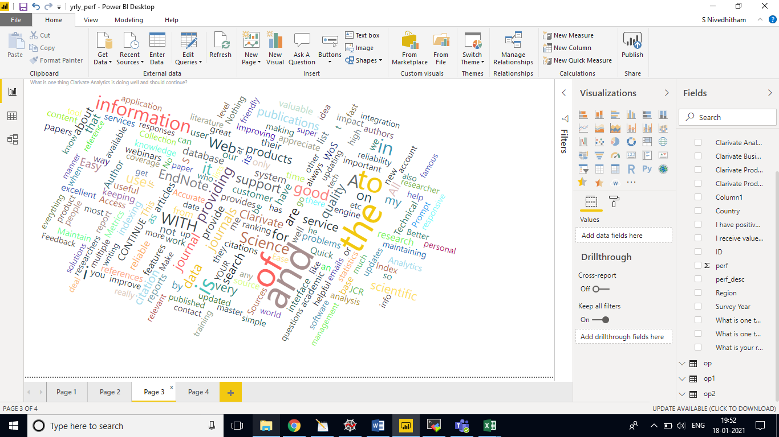

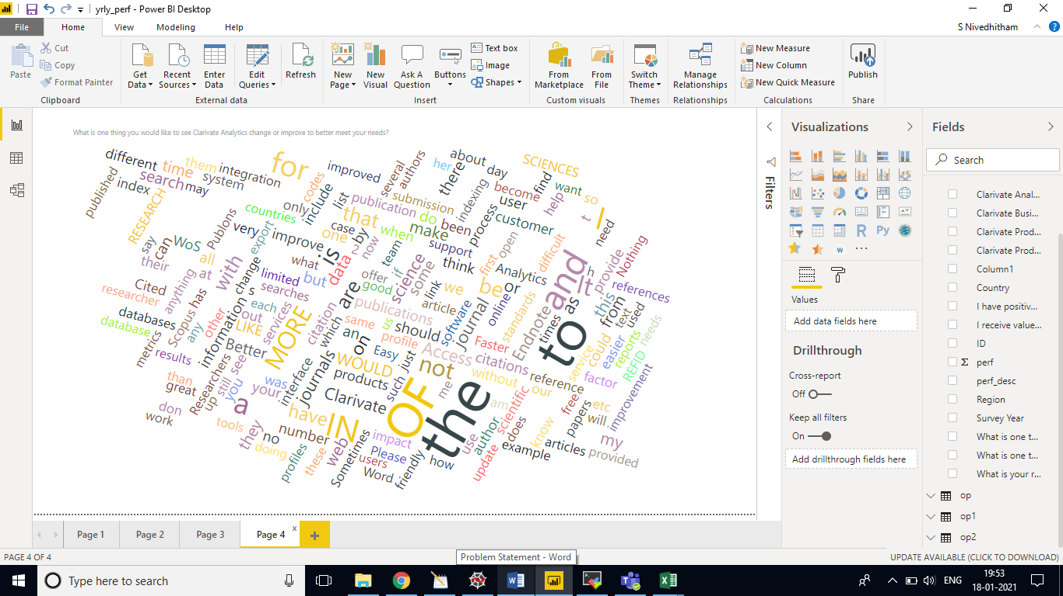

Other Insights:

Region wise usage measurement of Clarivate Products